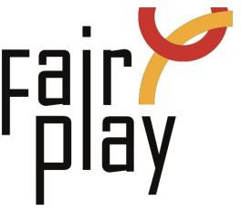

SUBMISSION OF CANDIDACY QUESTIONNAIRE FOR C.I.F.P. AWARDS
NOMINATIONS FOR THE YEAR 2025

Jacques Rogge World Fair Play Trophy - 2025
Jacques Rogge World Fair Play Trophy for the Youth to an athlete, or a team UNDER 20, for a gesture of fair play.

1. Details of the Youngster(s) proposed for the nomination:

Name: *
Country: *
E-mail: *

Profession or current occupation / school: *

Organization connected:

2. Her/ his act of fair play:

Date of the act: *

Place of the act (city, country): *

Name of the competition: *

3. Description of the act or gesture: (max. 50 words): *

4. Initiative - Emphasize the initiative of the girl(s) or boy(s): *

5. Source (preferably in English): *

6. Details of the person or organization submitting this nomination:

Name: *

E-mail: *

Please attach all available supporting evidence (photos, press clippings, reports etc.) justifying this nomination as well as a PHOTO

